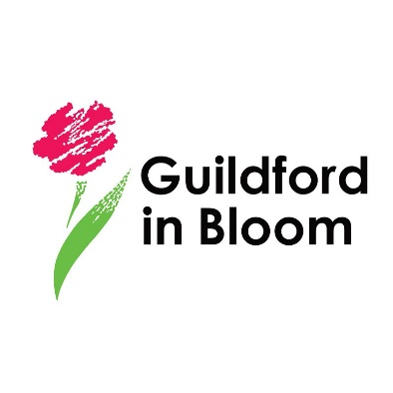
Get your Event Listed on www.GuildfordInBloom.com

Events must be related to gardening, gardens, horticulture, wildlife or other
Related topic.

Simply complete this form and email it to: Info@GuildfordinBloom.com together with a jpeg image.

Your Name (will not be published)
Your email address (will not be published)
Your Phone Number (will not be published)
Your Organisation
Event Name
Event Venue | Address:
 | Town
 | County
 | Post Code
Event Date(s)
Event Start Time
Event Finish Time
Event Description (max 100 words – longer descriptions will be edited)
Ticket Price | Adult:
 | Child: (give ages)
 | Concession
 | Group
 | Other
Website
Box office link if tickets required
Box Office Phone Number
Event Email for queries

Remember to attach a jpeg image which needs to have the same name as the event.

Now email this form together with your image to info@guildfordinBloom.com

